

CSE3506- Essential of Data Analytics

J Component -Project Report
Winter Semester 2022-23

Topic: Comparative study of different ensemble models on Wine Quality
By

UDAY SINGH SHERGILL 20BCE1806
SHIVAM JAISWAL 20BPS1148
HIMANSHU BAID 20BCE1159

Submitted to

Dr. TRILOK NATH PANDEY
Assistant Professor, SCOPE, VIT, Chennai

School of Computing Science and Engineering
VIT Chennai
Vandalur - Kelambakkam Road, Chennai - 600 127 WIN SEM 22-23

1
2
BONAFIDE CERTIFICATE

This is to certify that this project entitled “Comparative study of different ensemble models on Wine Quality” submitted in partial fulfilment of the degree of B.Tech to Vellore Institute of Technology, Chennai, done by Mr. Uday Singh Shergill, Regd. No.20BCE1806, Mr. Shivam Jaiswal, Regd.No.20BPS1148, Mr. Himanshu Baid, Regd. No.20BCE1159 is an authentic work carried out the project work for the subject “Essential of Data Analytics” under my supervision for the winter semester 2022-23 by them under my guidance. The matter embodied in this project work has not been submitted earlier for award of any degree or diploma to the best of our knowledge and belief.

SIGNATURE

Dr TRILOK NATH PANDEY

FACULTY NAME

Assistant Professor SCOPE
3
ACKNOWLEDGEMENT

We would like to convey our sincere gratitude to our project advisor,
Dr. Trilok Nath Pandey, SCOPE, for his constant support and insightful advice that he provided to us in a pleasant manner during the project work as well as for inspiring us to complete the study on the topic “Wine Quality Analysis”.

We would want to take this opportunity to thank the faculties of the college for their guidance and support throughout the project.

Lastly, we wish to express our gratitude to our parents, relatives, and friends for their support throughout the execution and helped us in every possible way and displayed appreciation for our project and for the opportunity they provided us in undergoing this course at such a prominent institution.
TABLE OF CONTENTS
4

CHAPTER | TITLE | PG. NO.
1 | Bonafide | 2
2 | Acknowledgement | 3
3 | Abstract | 5
4 | Introduction | 6
5 | Literature Survey | 7
6 | Architecture Design | 10
7 | Module Explanation | 11
8 | Implementation | 13
9 | Performance Analysis | 45
10 | Limitations | 48
11 | Conclusion | 49
12 | Future Works | 50
13 | Appendix-I (Codes) | 50
14 | Reference | 63
15 | What we have done to make our project public. | 63

ABSTRACT
5

Drinking wine may not be something we Indians may look up to but when we consider the broader world, wine drinking is a culture followed by many countries and people regard it essential for their living, and such wine is not cheap either. So, people expect to get quality goods for the money they pay. But there always are a set of people who aim to cheat people out of their money and earn some profit. It also involves health risks since drinking bad wine may cause altitude of problems for both those who drink it and are around them in various ways.

To produce good tasting and quality wine, there are many factors involved in this to get the same. Also, to check for the quality and taste we mostly hire wine tasters and get the opinion of each wine, using this data we analyse which wine has been preferred by most of the wine tasters. But it is not always feasible and accurate to predict the best factors effecting the wine without studying them.
So, to solve this setback our project aims predict the quality of a wine sample based on its physicochemical factors which will involve the creation of training sets using the data collected from the vineyards and testing based on new wine to test the quality. This will help the wine producers to improve their quality of wine. Using this analysis and result they can extract the important factors effecting the quality and taste of wine. Working on the concentrations of such factors will help them to increase the quality and the produce the wine that is preferred by the consumers at a higher rate. This will also increase their sale and give an interest at an increasing rate.

INTRODUCTION
6

Wine industry shows a recent growth spurt as social drinking is on the rise. The price of wine depends on a rather abstract concept of wine appreciation by wine tasters, opinions among whom may have a high degree of variability. Pricing of wine depends on such a volatile factor to some extent. Another key factor in wine certification and quality assessment is physicochemical tests which are laboratory-based and take into account factors like acidity, pH level, the presence of sugar and other chemical properties.

For the wine market, it would be of interest if human quality of tasting can be related to the chemical properties of wine so that certification and quality assessment and assurance process is more controlled. So, we want to study the importance of the features for the prediction of wine quality to see which yields the highest accuracy and to determine which features are the most indicative of a good quality wine.
We collected the dataset and used it as a source of description about each type of wine to analyse each variable. A predictive model developed on the dataset is expected to provide guidance to vineyards regarding quality and price expected on their produce without heavy reliance on the volatility of wine tasters. A prescriptive model developed on the dataset is expected to provide knowledge to vineyards about best quality wines and prescribing which variable is their wine lacking in order make it better quality for the consumers.
LITERATURE REVIEW

- Research [1] shows that progress and human development are faster than before because of the Industrial Revolution. To meet the increasing demand, product manufacturers are also increasing their profits. As a result, poor quality food persists, posing a serious health risk to humans. We now need a system to predict the quality of the drinks and food we consume. In this research article, focus on the quality of red wine.

This document includes alcohol, residual sugar, density, etc. has important features such as Different tests are done to evaluate our proposed method, such as accuracy and precision. Our proposed framework achieves an accuracy of 98.36%, outperforming previous recordings. The authors of article

"Toast analysis for wine: Using stacked generalization to predict wine preferences" [2] explain how perceptions of wine quality arise from complexity around taste characteristics.

Therefore, it would be better to provide a more objective, data-driven approach to measuring alcohol preferences. Inspired by previous work using machine learning algorithms to model wine preferences, this work offers an integrated approach that predicts the quality level of wine samples based on physicochemical use characteristics.

The results show that the proposed system meets many good standards, including those recommended by motivation research. Additionally, the proposed method provides a simple concept that is important for understanding the relationship between predicted variables and is applied to both simulated and real paper. Given the predictive power of clothing use, especially when identified, physicians can use the following methods to use truth and negative thoughts to reveal their alcohol preferences.

- A 2019 literature review published in "IEEE Proceedings of the Industry" examined machine learning applications for predictive analytics based on sensor data. The authors found that learning models such as support vector machines, decision trees, and random forests were used to predict wine quality using measured data such as temperature, pH, and sweet content. The review also highlights the potential of machine learning to improve wine production processes and improve wine management. A literature review published in the
2021 IEEE Sensors Journal examines the use of machine learning for better prediction based on nasal data. The authors demonstrated the use of learning models such as negative power distribution, support vector machine, and decision trees to predict wine quality using e-nose data. The review also highlights the potential of machine learning in creating a low-cost and non-invasive way to assess wine quality. The risk of this process is that because the vineyards are old they may try to confuse the foundation board to change their results, which can result in insufficient information that makes the whole process controversial.

ARCHITECTURE DESIGN
10

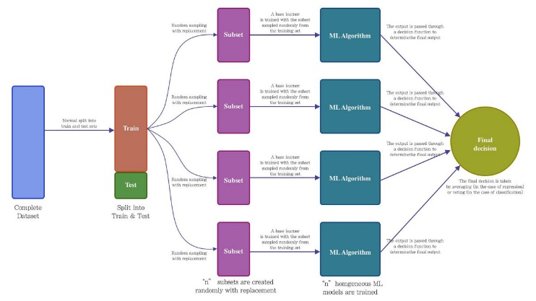

MODULE EXPLAINATION

  - Define the Problem:
- Show the contribution of each factor to the wine quality in your model
- Show which features are more important in determining the wine quality
- Show which features are less important in determining the wine quality

  - Data Gathering and understanding:
- Our analysis will use Wine Quality Data Set, available on the UCI machine learning repository (https://archive.ics.uci.edu/ml/machine-learning-databases/wine- quality/winequality.csv).
- The dataset contains a total of 12 variables, which were recorded for 4,898 observations. This data will allow us to create different regression models to determine how different independent variables help predict our dependent variable, quality. Knowing how each variable will impact the wine quality will help producers, distributors, and businesses in the red wine industry better assess their production, distribution, and pricing strategy.
- The aim of our project is to analyze wine dataset to predict the quality of a wine sample based on its physicochemical factors which will involve the creation of training sets using the data collected from the vineyards and testing based on new wine to test the quality.
- In our project the training and testing sets are created from the dataset we acquired and they will be used during the model building to provide a sample for the real- world solution.

  - Data Preparation and Exploration:
- Data Preparation:
  - First step to clean and prepare the data for analysis
  - First, we check the data types focusing on numerical and categorical.
  - Then, identifying missing values existing in our data set.
  - Lastly, checking for problems like outliers and abnormal distributions.
11
- Data Exploration:
12
  - Helps in interpreting each feature of wine data.
  - To know which variables are likely to affect the quality of wine the most.

  - Modelling with algorithms:

Decision Tree Algorithm

This code imports necessary libraries for data processing, model training, and evaluation.
Here, the data is split into input variables (X) and target variable (y). The input variables consist of all the columns except for the 'quality' column, which is the target variable.

Split the data into training and testing sets using the train_test_split function from the sklearn library. The test_size parameter specifies that 20% of the data will be used for testing, and random_state sets the seed for the random number generator used by the function for reproducibility.

Then we use the trained decision tree to make predictions on the test set and calculates the accuracy of the model using the accuracy_score function from the sklearn library. The accuracy is then printed to the console, and the lengths of y_test and y_pred are printed for information.

After that we converts y_pred and y_test to numpy arrays, subtracts them element-wise, and converts the resulting numpy array to a list called 'differece', which is then printed to the console.
Plot histograms of the differences between y_pred and y_test, as well as histograms of y_test and y_pred separately, using the matplotlib library.
Extract the number of times the value '4' appears in both y_test and y_pred separately.
Finally, plot a scatter to represent the relationship.

Bagging Algorithm

The code is performing various operations on the wine dataset, using several machine learning algorithms and evaluating their performance.

It’s using the sklearn library to create an ensemble Bagging classifier that is trained on the wine dataset. It first sets a random seed, then creates a Decision Tree Classifier with a maximum depth of 5 and sets the number of estimators to 6. The classifier is then fit on the training data (X_train, y_train), and the resulting model is stored in the variable mdl.

It again creates a Bagging classifier, but with different parameters. This time it sets the number of estimators to 100, the maximum samples to 0.8, and enables the out-of-bag score calculation. The classifier is then fit on the test data (X_test, y_test), and the out-of-bag score is printed.

Then we create a Decision Tree Classifier and fits it on the entire wine dataset (X, Y), and then calculates the accuracy score of the model.

The next block of code uses the Decision Tree Classifier to create a visual representation of the decision tree.

There we use the Bagging classifier with a Decision Tree Classifier as an estimator to perform 5-fold cross-validation on the wine dataset, and prints the average accuracy score.
We use the same Bagging classifier as in the previous step, but this time, it uses 10-fold cross-validation to evaluate the model's accuracy.

The final block of code calculates the confusion matrix and classification report for the model using the test data, and then visualizes the confusion matrix using a heatmap.

In summary, the code is performing various operations on the wine dataset, including training and evaluating machine learning models, visualizing decision trees, and calculating performance metrics such as accuracy, confusion matrix, and classification report.

XGBoost Algorithm:

This code block imports the necessary libraries for the code to run, including pandas and numpy for data manipulation, GridSearchCV and KFold for cross-validation, train_test_split for splitting data into training and testing sets, XGBoost for the gradient boosting algorithm, and various metrics functions.

This code block imports the seaborn library, which is used for data visualization, but it doesn't actually prepare the dataset.

This code block splits the dataset into training and testing sets, where 30% of the data is reserved for testing. X_train and y_train are the training features and labels, respectively, while X_test and y_test is the testing features and labels, respectively.

This code block trains an XGBoost regression model using the training data. The model is defined with the objective of minimizing the squared error, with 100 estimators, a learning rate of 0.05, and a maximum depth of 5.

This code block evaluates the XGBoost model using the testing data. The predicted values for the testing data are generated using the predict() method, and accuracy and mean squared error metrics are calculated using the predicted values and the actual labels. The results are then printed.

This code block performs hyper parameter tuning for the XGBoost model. The hyper parameters to tune are maximum depth, learning rate, and number of estimators. A GridSearchCV object is created with the xgb_model_tuned as the estimator, params as the parameter grid to search, and a cross-validation of 3. The best parameters are then printed.

AdaBoost Algorithm

The code is using the AdaBoost classifier algorithm from the scikit-learn library to build a machine learning model to predict outcomes in two different datasets.

In the first dataset, the code reads wine quality data from a CSV file and splits it into training and testing sets. The AdaBoost Classifier model is then trained on the training data, and its accuracy is evaluated on the testing data.

In the second dataset, the code generates a synthetic dataset using the make classification function from scikit-learn. Again, the AdaBoostClassifier model is trained on the training data and evaluated on the testing data.

In the third example, the code uses the AdaBoost classifier to train a decision tree classifier on a breast cancer dataset. The accuracy of the model is evaluated, and then k-fold cross-validation is used to further validate the model's performance. Finally, the confusion matrix and classification report are printed to show the model's performance on the test set, and a heatmap of the confusion matrix is plotted using the seaborn library.

  - Performance Metrics:

In data analytics, accuracy, precision, recall, support, and F1-score are commonly used metrics to evaluate the performance of different ensemble techniques. Here's what each of them represents:

Accuracy: Accuracy is the proportion of correct predictions out of the total number of predictions made. In other words, it measures how well the model is able to classify the data correctly.

Precision: Precision is the proportion of true positive predictions out of the total number of positive predictions made. In other words, it measures how many of the positive predictions made by the model are actually correct.

Recall: Recall is the proportion of true positive predictions out of the total number of actual positive instances in the dataset. In other words, it measures how well the model is able to identify all the positive instances in the dataset.

Support: Support is the number of instances in the dataset that belong to a particular class.

F1-score: F1-score is the harmonic mean of precision and recall. It provides a single score that balances both precision and recall, and is often used as an overall measure of the model's performance.

When comparing different ensemble techniques, you would typically look at these metrics for each technique and choose the one that performs the best overall. However, it's also important to consider other factors such as computational complexity, scalability, and interpretability when selecting an ensemble technique.

VI. MODULES USED

    - Decision Tree

Decision Tree is the most powerful and popular tool for classification and prediction. A Decision tree is a flowchart-like tree structure, where each internal node denotes a test on an attribute, each branch represents an outcome of the test, and each leaf node (terminal node) holds a class label.
Construction of Decision Tree: By dividing the source set into subgroups based on an attribute value test, a tree can be "learned". It is known as recursive partitioning to repeat this operation on each derived subset. When the split no longer improves the predictions or when the subset at a node has the same value for the target variable, the recursion is finished. Decision tree classifier building is ideal for exploratory knowledge discovery because it doesn't require parameter configuration or domain understanding. High-dimensional data can be handled via decision trees

Decision Tree Representation: Decision trees categorise instances by arranging them in a tree from the root to a leaf node, which gives the instance's categorization. As seen in the above diagram, to classify an instance, one tests the attribute given by the root node of the tree before continuing down the branch of the tree that corresponds to the attribute's value. The subtree rooted at the new node is then subjected to the same procedure once more.
According to whether a specific morning is ideal for playing tennis, the decision tree in the above diagram assigns a classification to each leaf and returns that classification. (in this case Yes or No).

    - ADA BOOSTING
AdaBoost, also called Adaptive Boosting, is a technique in Machine Learning used as an Ensemble Method. The most common estimator used with AdaBoost is decision trees with one level which means Decision trees with only 1 split. These trees are also called Decision Stumps.
To apply AdaBoost to wine quality prediction, you can follow these general steps:
- Collect and preprocess the wine quality data. This may include cleaning the data, removing duplicates and outliers, and splitting the data into training and testing sets.
- Choose an appropriate machine learning model to use as the "weak" classifier for AdaBoost. For wine quality prediction, you can use algorithms such as decision trees, random forests, or support vector machines (SVMs).
- Train the weak classifier on the training data.
- Use the AdaBoost algorithm to combine multiple instances of the weak classifier into a single "strong" classifier. In AdaBoost, each instance of the weak classifier is given a weight based on its accuracy, and the final prediction is made by weighting the predictions of each weak classifier.
- Evaluate the performance of the AdaBoost classifier on the testing data. You can use metrics such as accuracy, precision, recall, and F1-score to measure the performance.
- If necessary, tune the hyperparameters of the AdaBoost algorithm to improve the performance.
- Once you are satisfied with the performance of the AdaBoost classifier, you can use it to make predictions on new, unseen wine quality data.

    - XG BOOSTING
XGBoost is a distributed gradient boosting library that has been optimized for quick and scalable machine learning model training. A number of weak models' predictions are combined using this ensemble learning technique to get a stronger prediction. Extreme Gradient Boosting, or XGBoost, is one of the most well-known and widely used machine learning algorithms because it can handle large datasets and perform at the cutting edge in many machine learning tasks like classification and regression.

Its effective handling of missing values, which enables it to handle real-world data with missing values without requiring a lot of pre-processing, is one of the key characteristics of XGBoost. Additionally, XGBoost has built-in support for parallel processing, making it possible to train models on large datasets in a reasonable amount of time.
Applications for XGBoost include click-through rate prediction, recommendation systems, and Kaggle competitions among others. Additionally, it is quite adaptable and enables speed optimisation by allowing for fine-tuning of numerous model parameters.
Extreme Gradient Boosting, or XGBoost, is a concept put out by University of Washington researchers. It is a C++ library that enhances the training process for gradient boosting.
Decision trees are generated sequentially in this approach. Weights are significant in XGBoost. Each independent variable is given a weight before being fed into the decision tree that forecasts outcomes. Variables that the tree incorrectly predicted are given more weight before being placed into the second decision tree. These distinct classifiers/predictors are then combined to produce a robust and accurate model. It can be used to solve problems including regression, classification, ranking, and custom prediction.

    - BAGGING
A machine learning ensemble meta-algorithm called bootstrap aggregating, commonly referred to as bagging, is created to increase the stability and accuracy of machine learning algorithms used in statistical classification and regression. It reduces variation and aids in preventing overfitting. Usually, decision tree approaches are where it is used. A specific instance of the model averaging approach is bagging.
A Bagging classifier is an ensemble meta-estimator that fits base classifiers each on random subsets of the original dataset and then aggregate their individual predictions (either by voting or by averaging) to form a final prediction.
To implement bagging for wine quality prediction, you can follow these steps:
- Split the wine dataset into training and test sets.
- Create multiple subsets of the training data using random sampling with replacement.
- Train a decision tree model on each subset of the training data.
- Use each model to predict the quality of the wine in the test set.
- Combine the predictions from all the models using either averaging or majority voting to get the final prediction.

Similarities between Bagging and Boosting:
Both of the widely used approaches, bagging and boosting, are consistently categorised as ensemble methods.

- Both ensemble procedures start with one student and produce N learners.
- Both use random sampling to produce various training data sets.
- By averaging the N learners, both get to their final judgement. (or taking the majority of them i.e Majority Voting).
- Both effectively lessen variance and offer greater consistency.

Differences between Bagging and Boosting

1. Bagging is the simplest way of combining predictions that belong to the same type whereas boosting is a way of combining predictions that belong to the different types.

2. Bagging aims to decrease variance, not bias whereas Boosting Aim to decrease bias, not variance.

3. In Bagging each model receives equal weight whereas in boosting Models are weighted according to their performance.

4. In bagging each model is built independently whereas in boosting New models are influenced by the performance of previously built models.

5. In bagging different training data subsets are selected using row sampling with replacement and random sampling methods from the entire training dataset whereas in boosting every new subset contains the elements that were misclassified by previous models.

  - Bagging tries to solve the over-fitting problem whereas Boosting tries to reduce bias.

7.If the classifier is unstable (high variance), then apply bagging and If the classifier is stable and simple (high bias) the apply boosting.

8. In Bagging base classifiers are trained parallelly. In Boosting base classifiers are trained sequentially.

9 Example: The Random forest model uses Bagging. Example: The AdaBoost uses Boosting techniques

Comparison of XGBoost and AdaBoost

- Loss function:
A variety of loss functions are used in the boosting technique. AdaBoost, also known as adaptive boosting, minimises the exponential loss function, which can make the algorithm more susceptible to outliers. Any differentiable loss function can be used with gradient boosting. AdaBoost is less resistant to outliers than the gradient boosting algorithm.

- Flexibility:
The first boosting algorithm with a specific loss function was called AdaBoost. Gradient Boosting, on the other hand, is a general technique that helps in the search for approximations to the additive modelling issue. Gradient Boosting is hence more adaptable than AdaBoost.

- Benefits:
AdaBoost works best with weak learners and minimises the loss function associated with every classification error. The technique can be used to improve the performance of decision trees and was primarily created for binary classification issues. The problem of the differentiable loss function is solved using gradient boosting. The method can be applied to problems involving classification and regression.

Shortcomings:

Gradient Boosting uses gradients to identify the weaknesses of the current weak learners, while AdaBoost uses high-weight data points to do the same.

Applying a basic machine learning algorithm:
Decision tree

We took the wine quality dataset from kaggle that has attributes (fixed_acidity, volatile_acidity,
citric_acid, residual_sugar chlorides, free_sulfur_dioxide, total_sulfur_dioxide, density, pH, sulphates, alcohol , quality)

Dataset

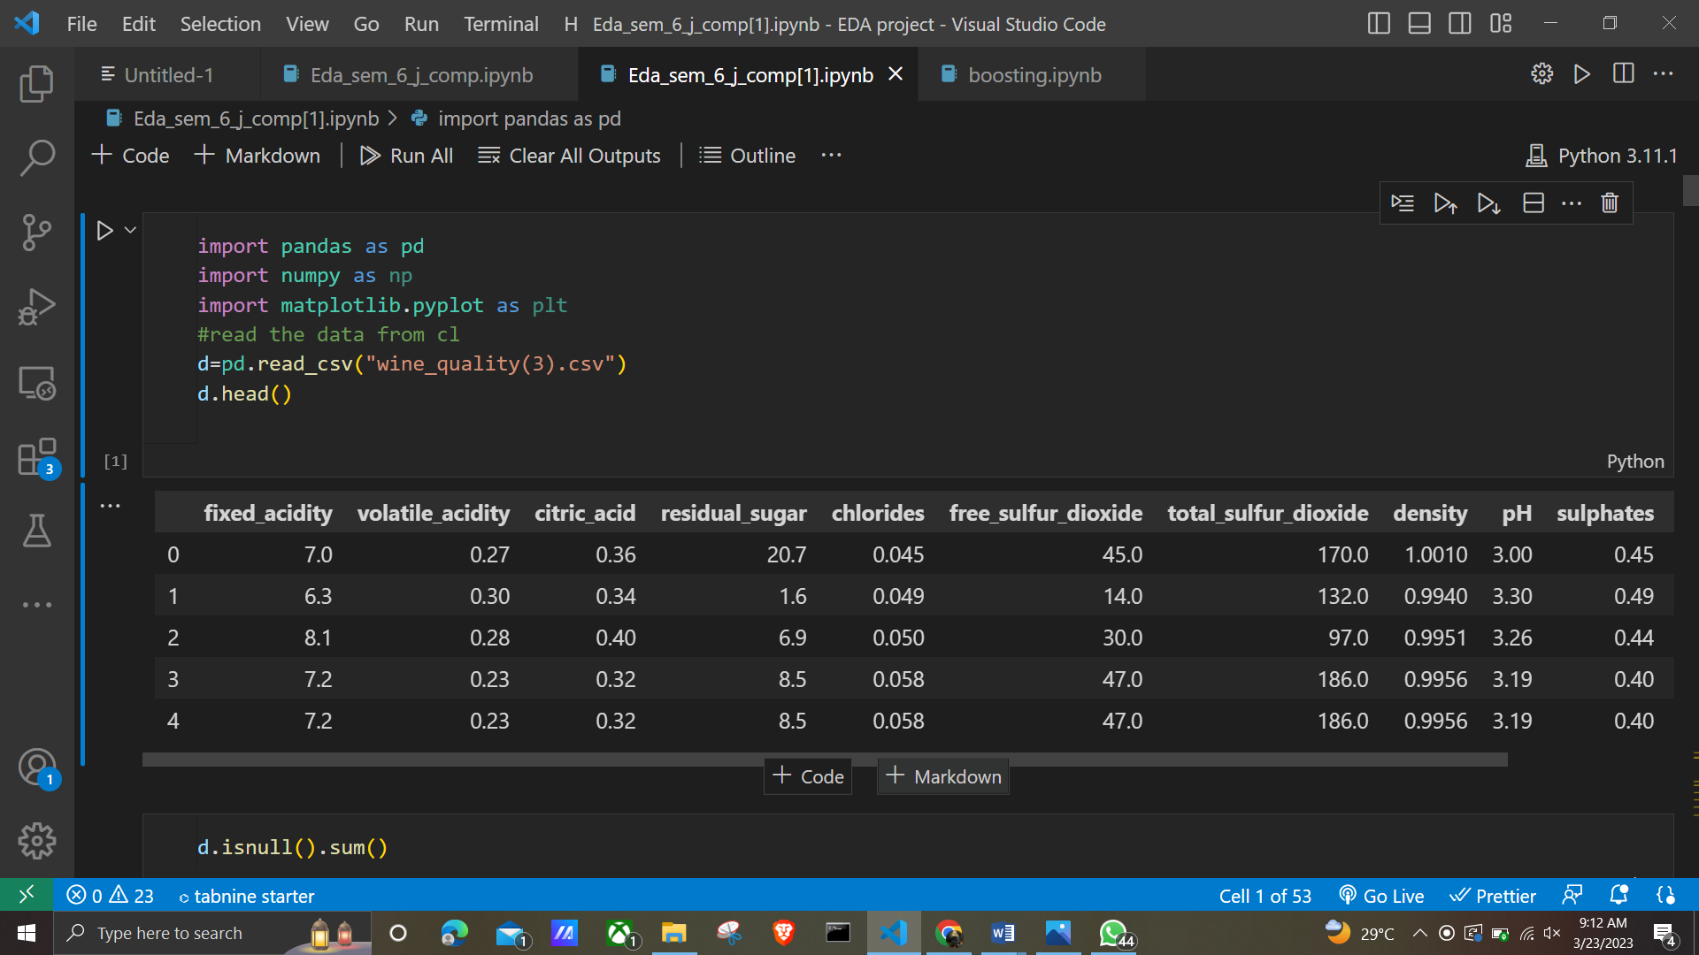

Figure1

IMPLEMENTATION

To see which variables are likely to affect the quality of red wine the most, I ran a correlation analysis of our independent variables against our dependent variable, quality. This analysis ended up with a list of variables of interest that had the highest correlations with quality.

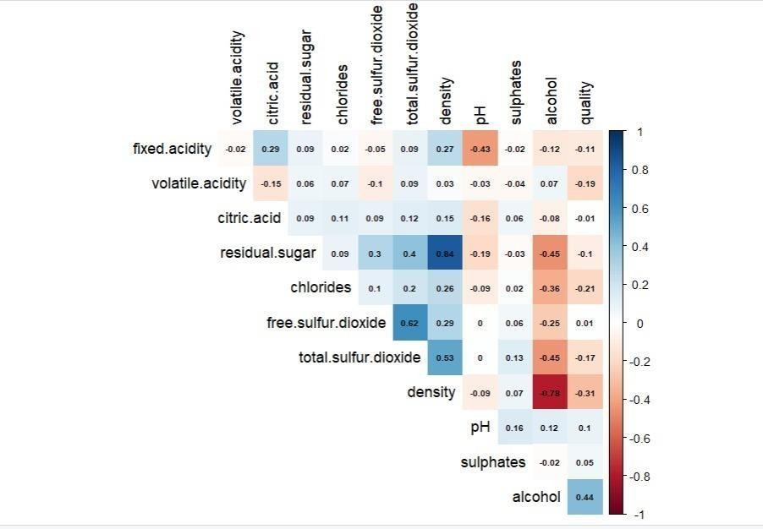
Figure2

In order of highest correlation, these variables are:
- Alcohol: the amount of alcohol in wine
- Volatile acidity: are high acetic acid in wine which leads to an unpleasant vinegar taste
- Sulphates: a wine additive that contributes to SO2 levels and acts as an antimicrobial and antioxidant
- Citric Acid: acts as a preservative to increase acidity (small quantities add freshness and flavour to wines)
- Total Sulphur Dioxide: is the amount of free + bound forms of SO2
- Density: sweeter wines have a higher density
- Chlorides: the amount of salt in the wine
- Fixed acidity: are non-volatile acids that do not evaporate readily

13
- pH: the level of acidity
14
- Free Sulfur Dioxide: it prevents microbial growth and the oxidation of wine
- Residual sugar: is the amount of sugar remaining after fermentation stops. The key is to have a perfect balance between — sweetness and sourness (wines > 45g/ltrs are sweet)

Next, for independent numerical variables, the first step to further analyze the relationship with our dependent variable was to create density plots visualizing the spread of the data.
Figure3

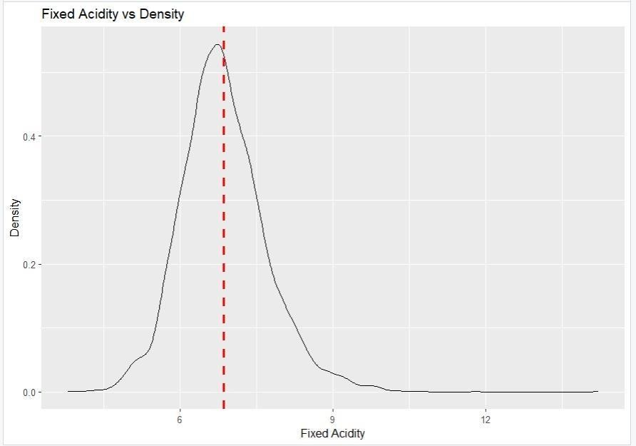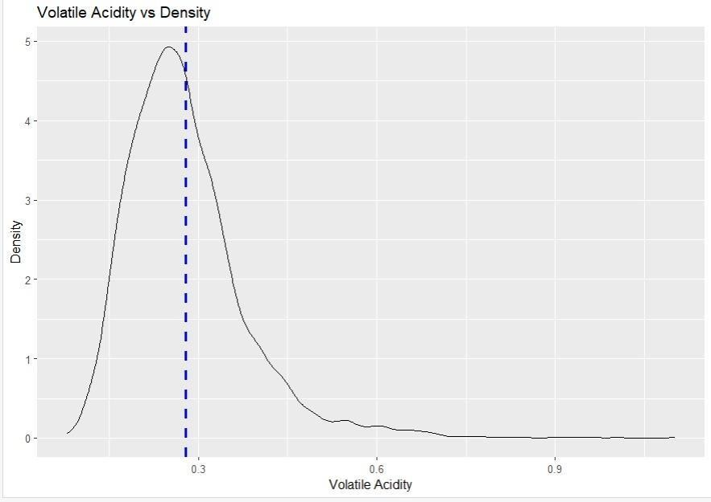
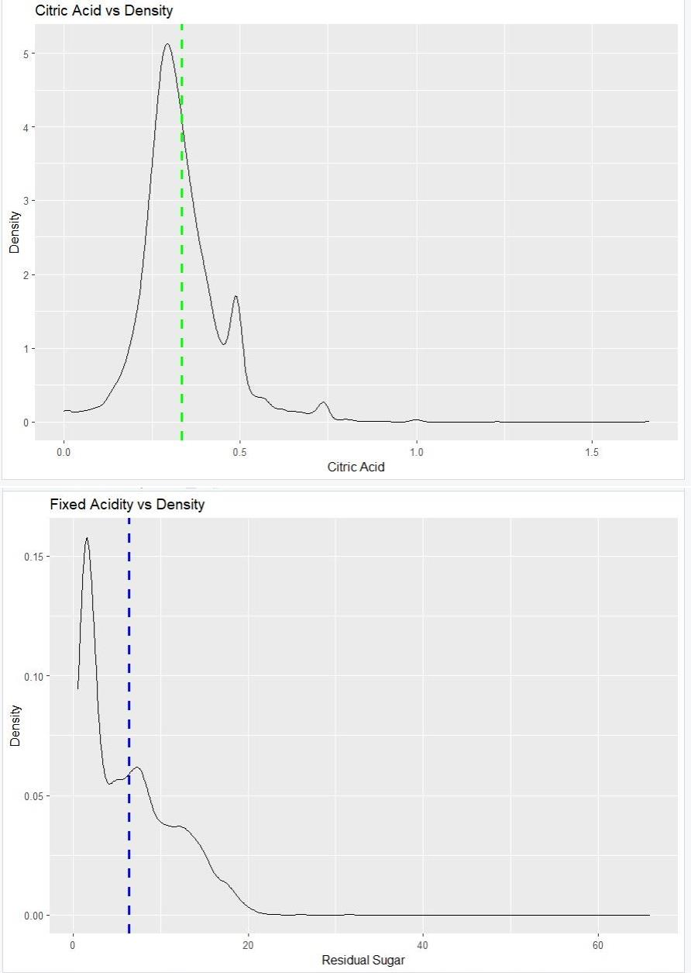
15

Figure4

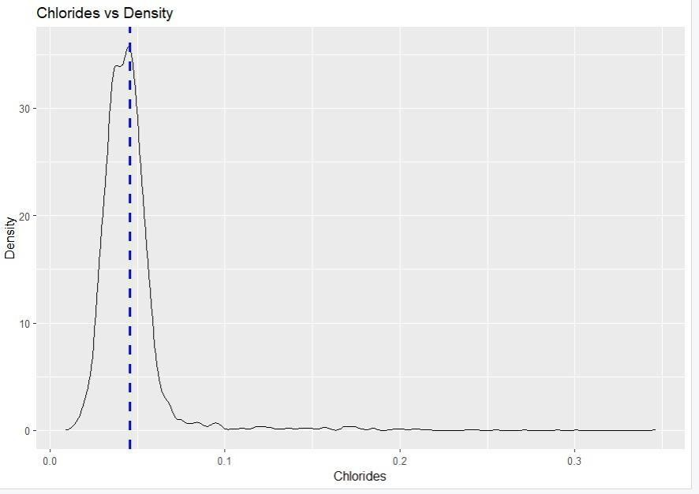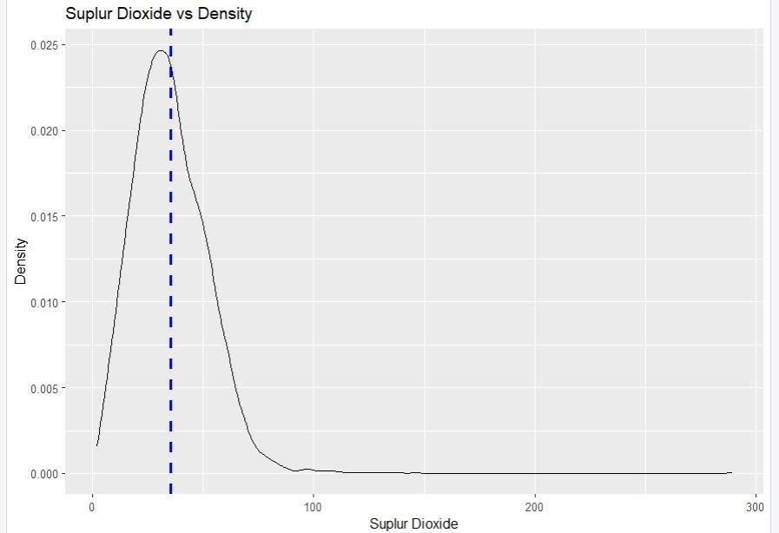
16

Figure 5

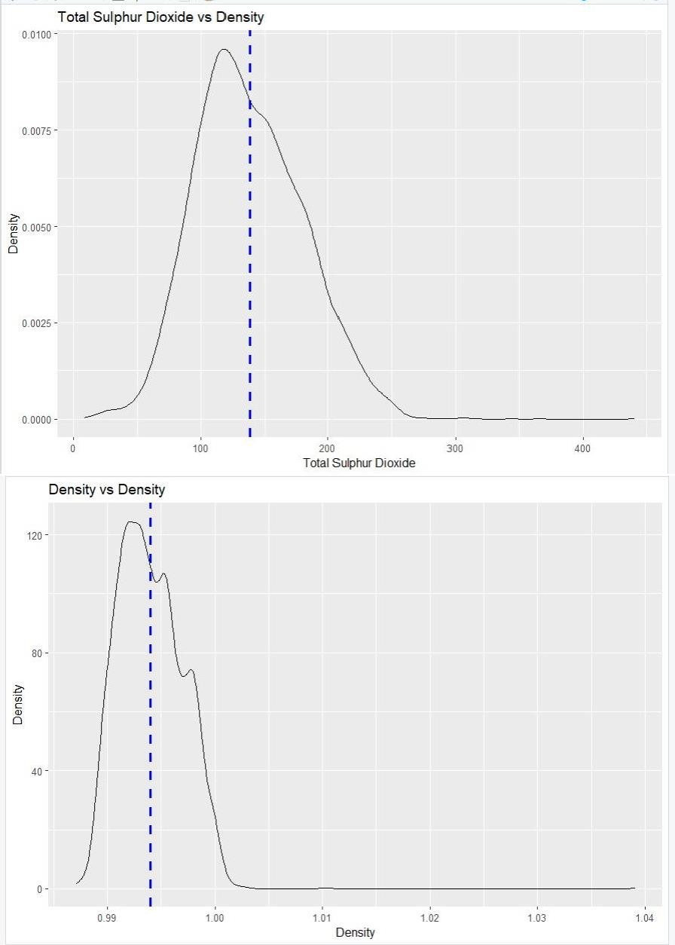
17

Figure 6

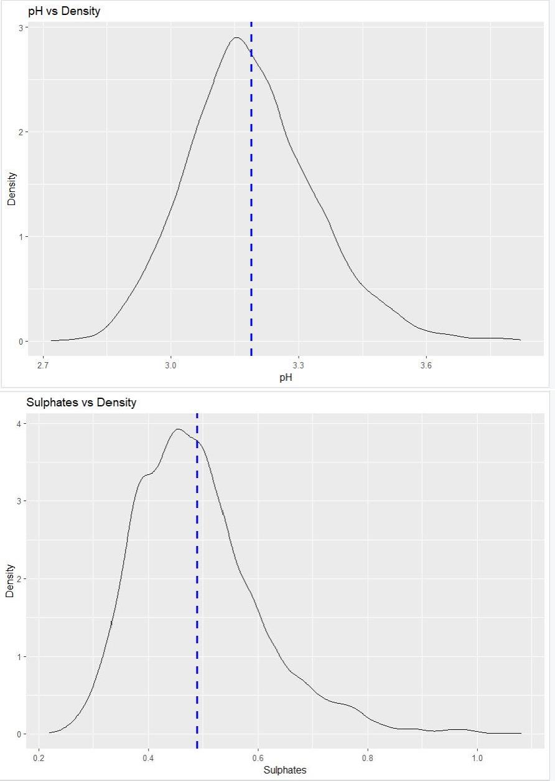
18

Figure 7

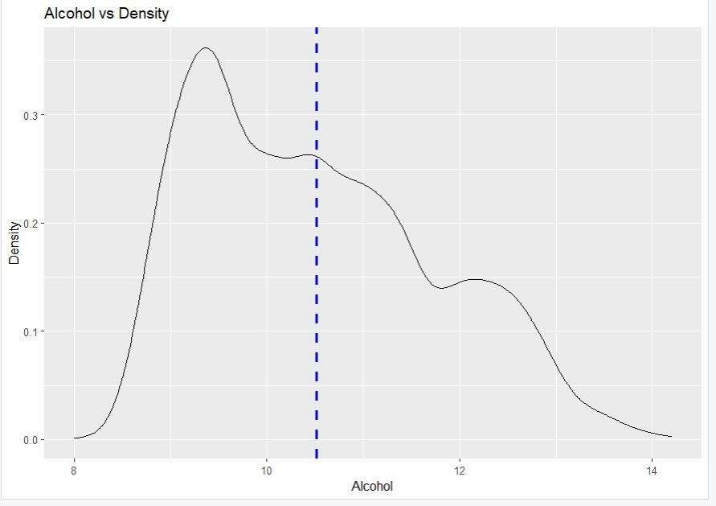
19

Figure 8

It can be seen that most red wines’ pH levels are always between 3–4 and chlorides — the amount of salt is most prevalent at level 0.1. After analysing the density plots, we plotted the interaction between our numeric variables of interest and our dependent variable of quality.
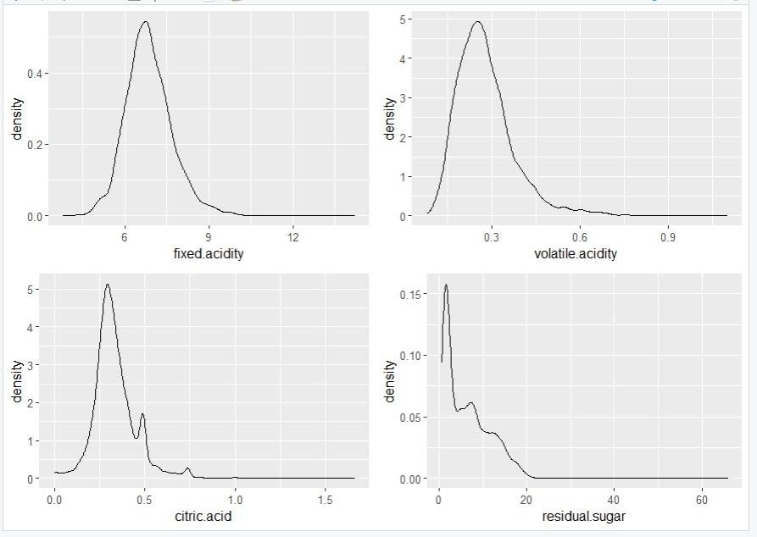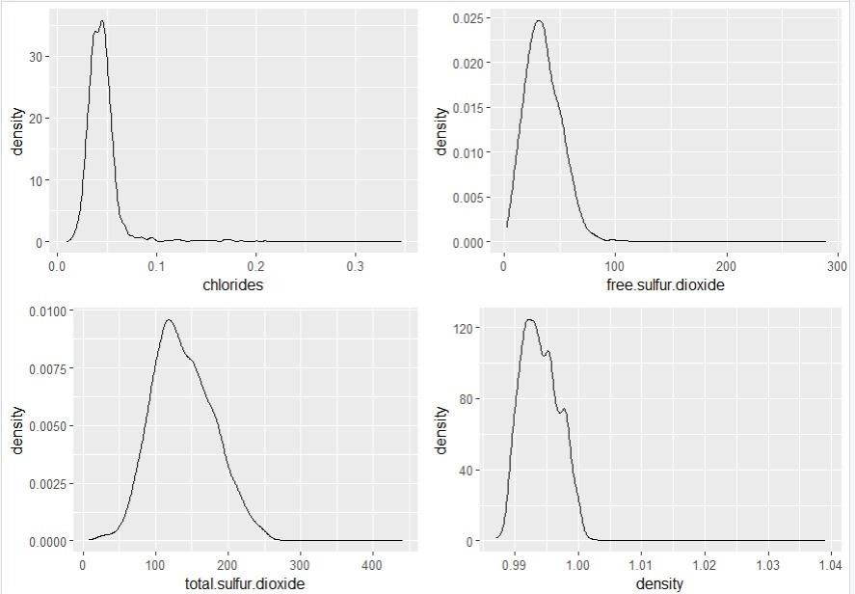
20

Figure 9

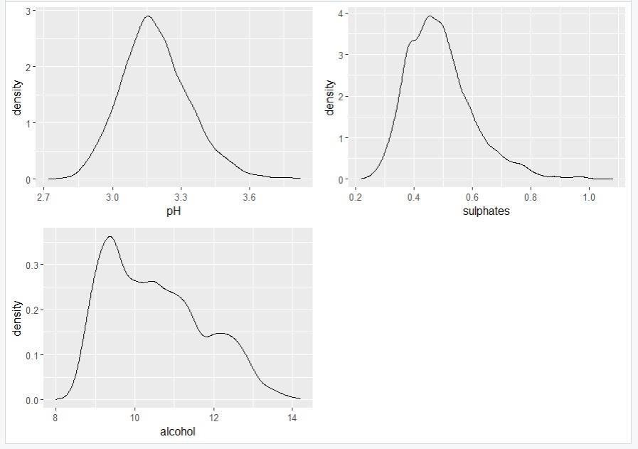
21

Figure 10
Now we plot Box Plot for each variable to get the Summary of each factor to predict and analyse the quality of wine. This will help us to predict each factor’s relation to alter the quality and taste wine.
22
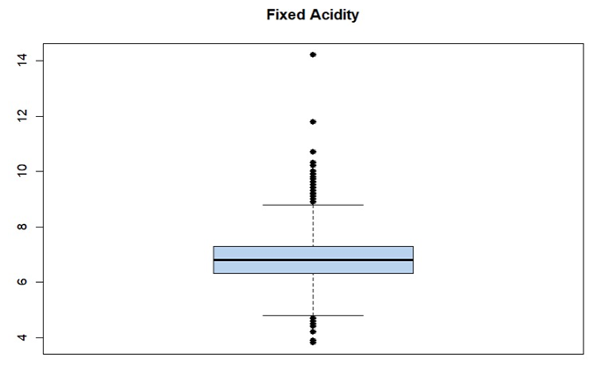

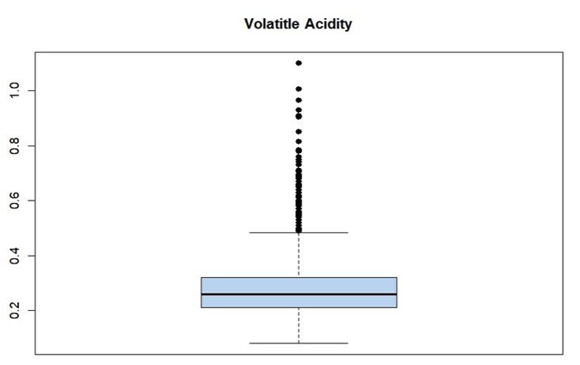

Figure 11

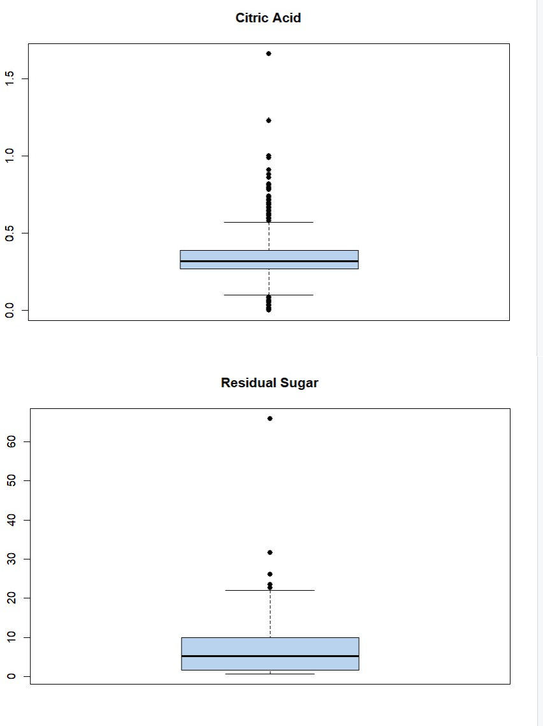
23

Figure 12

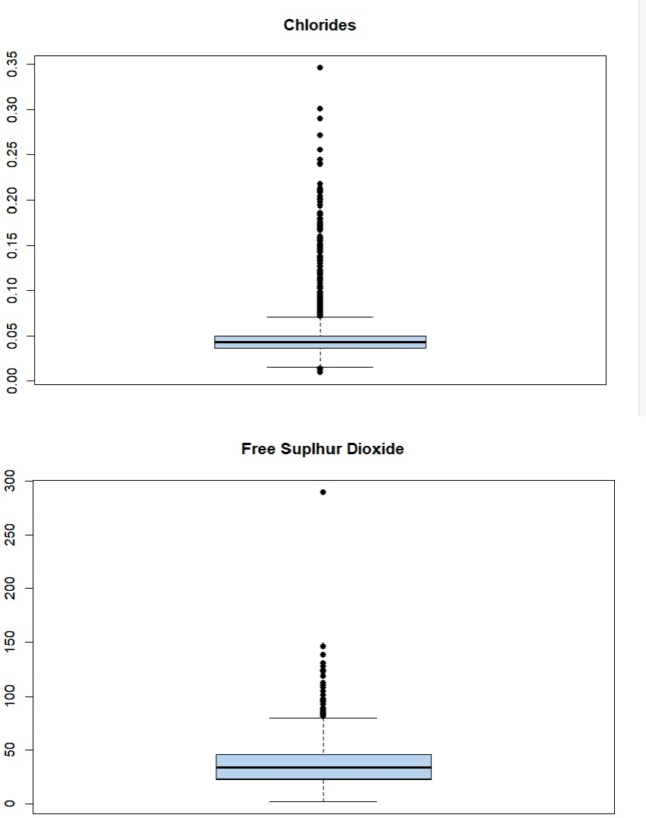
24

Figure 13

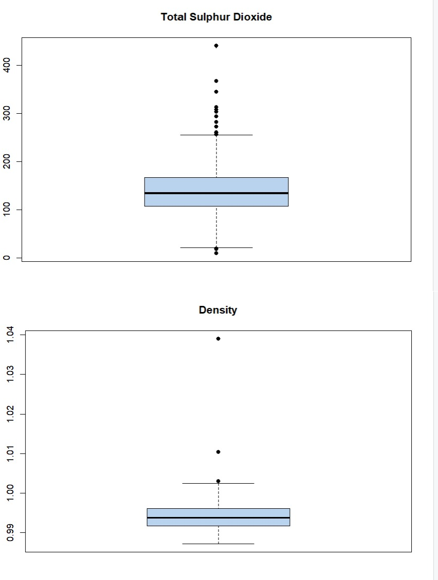
25

Figure 14

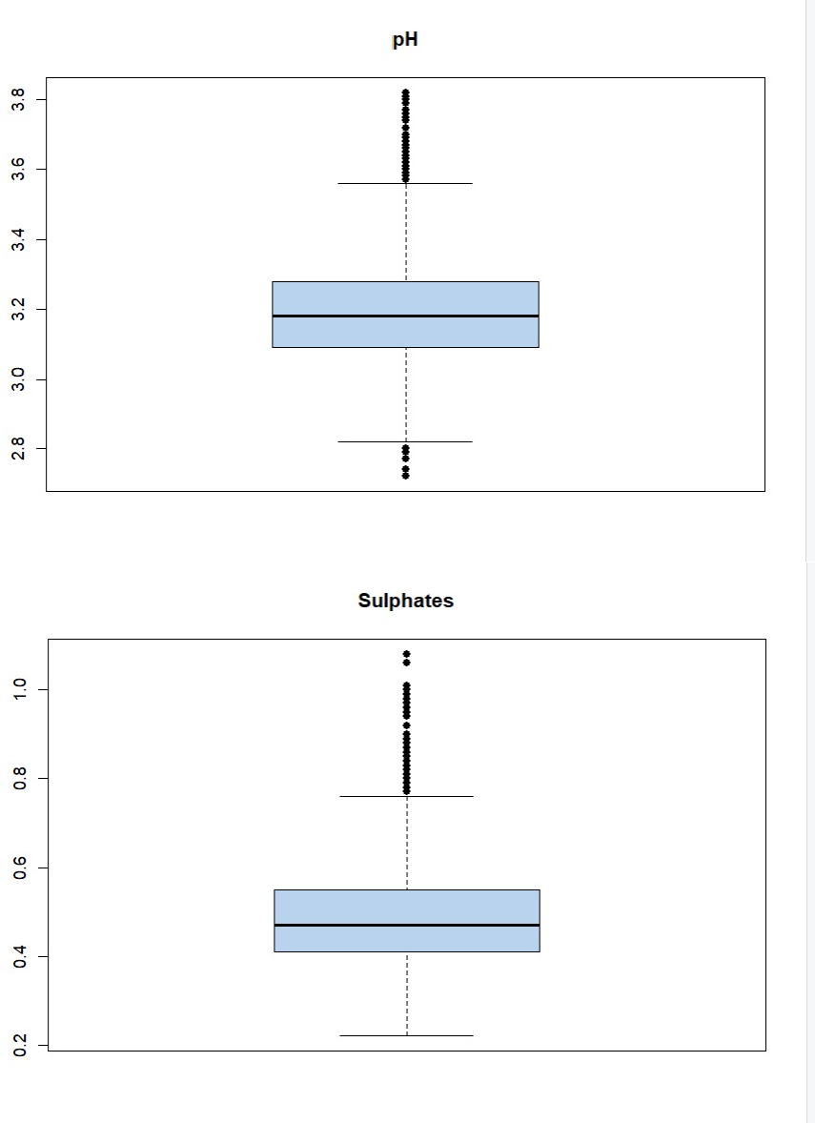
26

Figure 15

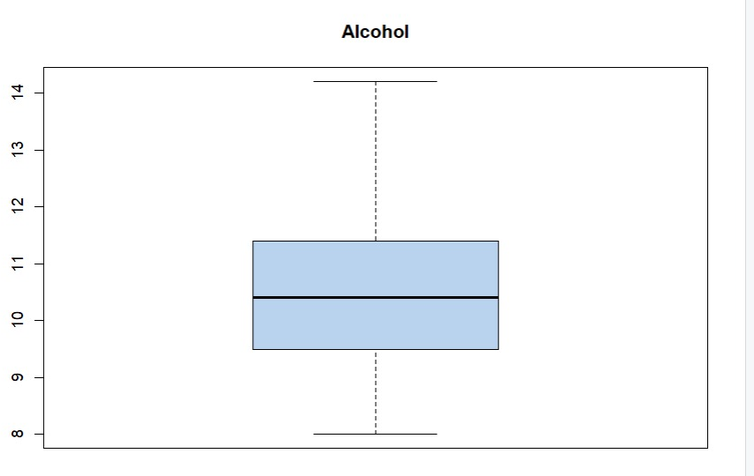
27
Figure1

From these box plots of each factor gives us the summary of its distributions and importance to predict the quality of wine. Now we inspect quality against variables of interest. We plot this in the required range of quality from 3-9 for each variable and fact.
29
30
31
32
33
34
35
36
Three different patterns can be observed. First, there are positive relationships between quality and critic Acid, alcohol, and sulphates. Even though wines with a higher level of alcohol may make them less popular, they should be highly rated in quality. Second, there are negative relationships between quality and volatile, acidity, density, and pH. It is reasonable that less sweet wines and a lower level of acidity are favoured in quality testings.
Last, these independent variables show no significant relationship with quality: residual. Sugar, chlorides, and total sulphur dioxide. To dive deep into relationships within independent variables and with quality, I built different three-dimensional plots. When inspecting the two variables, alcohol and volatile, acidity with quality, we can see that with red wines’ alcohol level between 9% to 12%, the level of volatile acidity decreases as the wines’ alcohol level increases. For higher alcohol content (>12%), the pattern reverses, implying high-quality wines’ popularity.
Finally, an interaction analysis using chlorides in relationships with alcohol and quality shows that the wines’ quality decreases when chloride level decreases at the alcohol before 12%. However, the quality of red wine increases as the chloride level increases at the alcohol level from 12%.
37
Last, we considered if the collinearity problem existed in our data. As a result of correlation analysis and VIF verification, we discovered some variables with slightly high correlations. To deal with such a potential problem, we will take advantage of the LASSO regularization technique in the next modelling part.
38

PERFORMANCE ANALYSIS
45

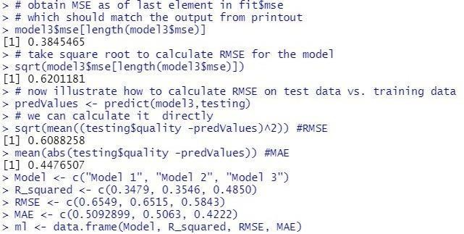
46

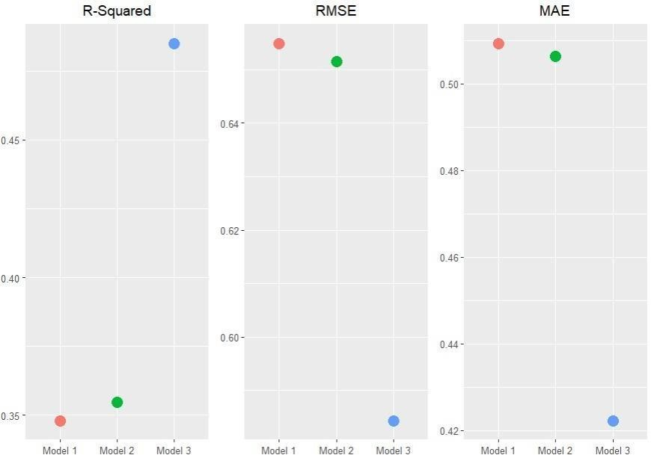

Figure 16

Clustering – Clearing Data

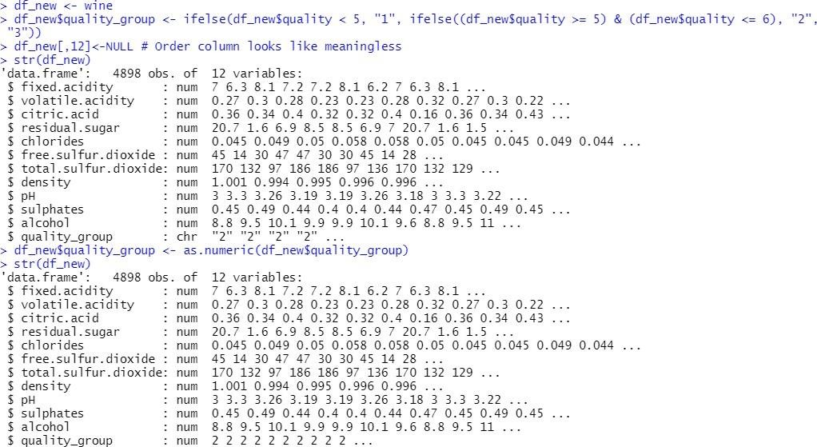
Standardizing Data
47
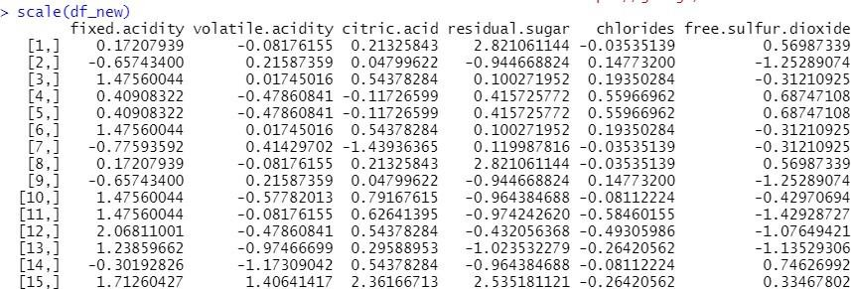
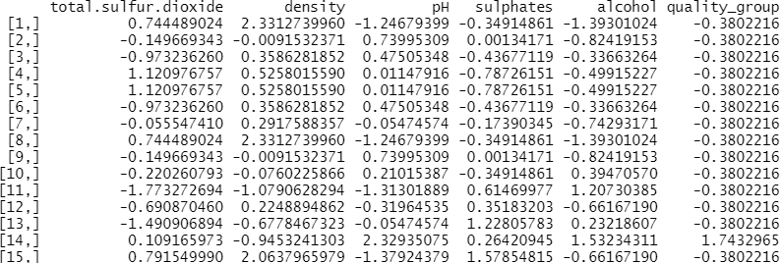
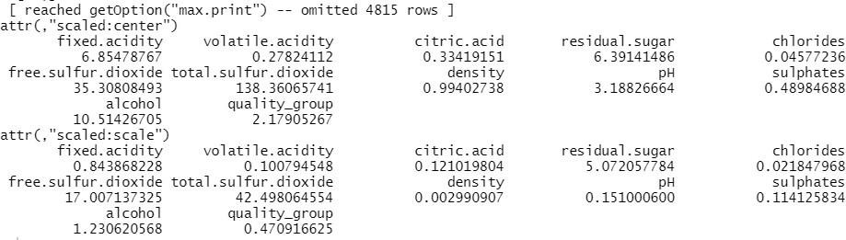

Getting Top 6 Records of Standardized Data using Head
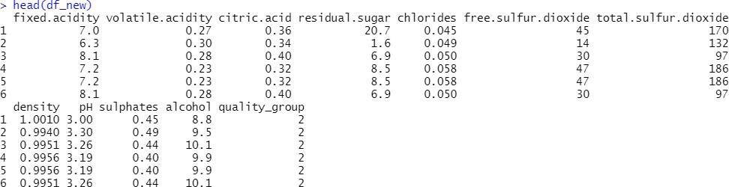

Confusion matrix:

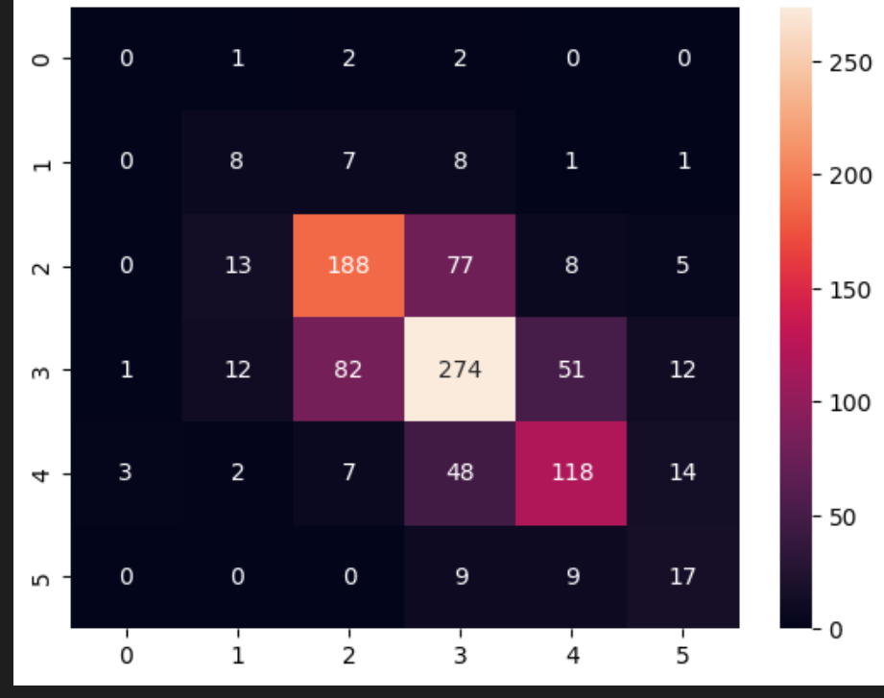

Figure 17

Y_test vs Y-pred(bar plot)
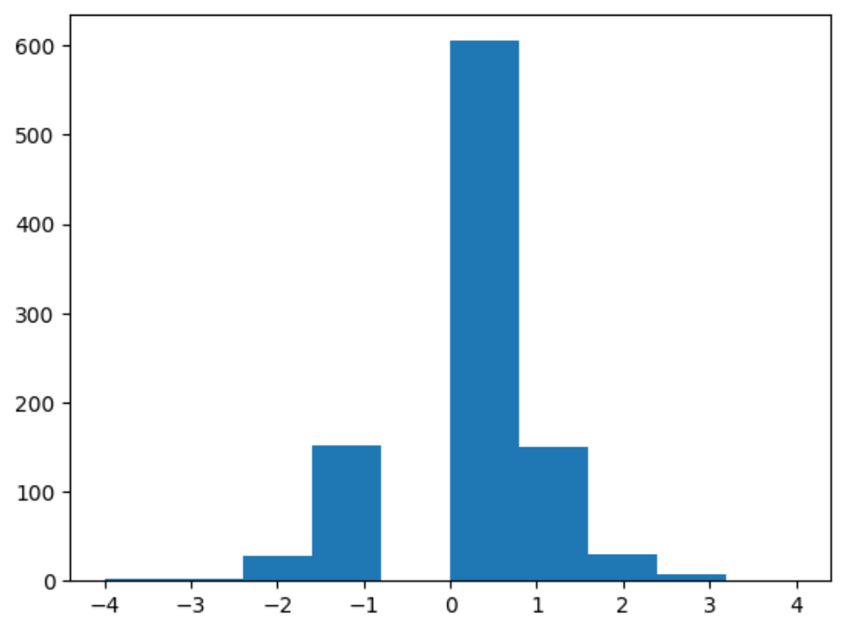

Figure 18

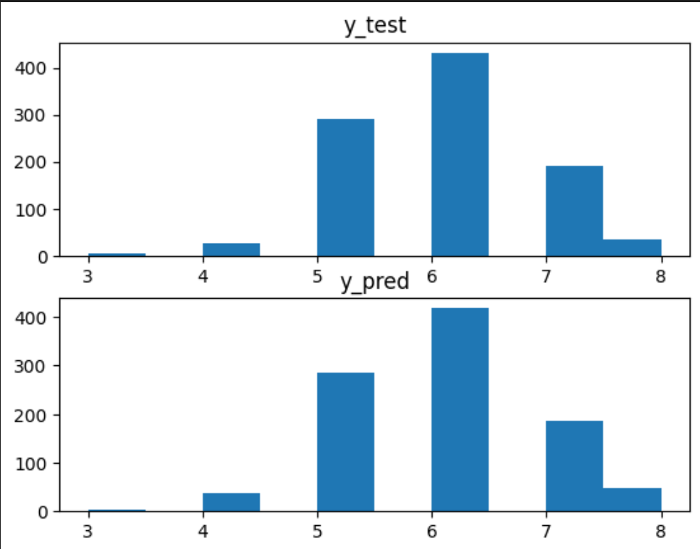

Figure 19

Scatter plot:

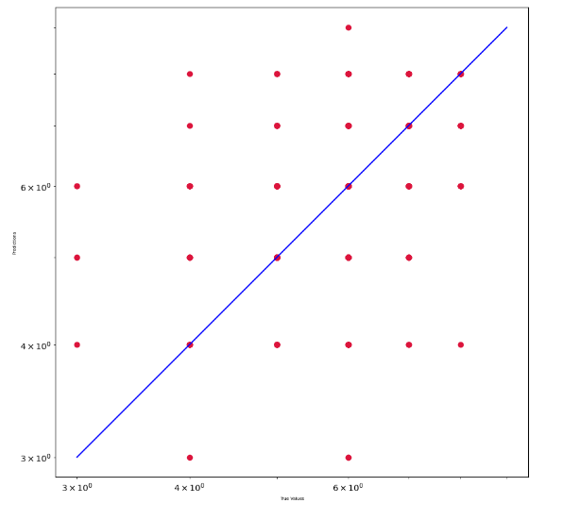
Figure 20

Decision tree:

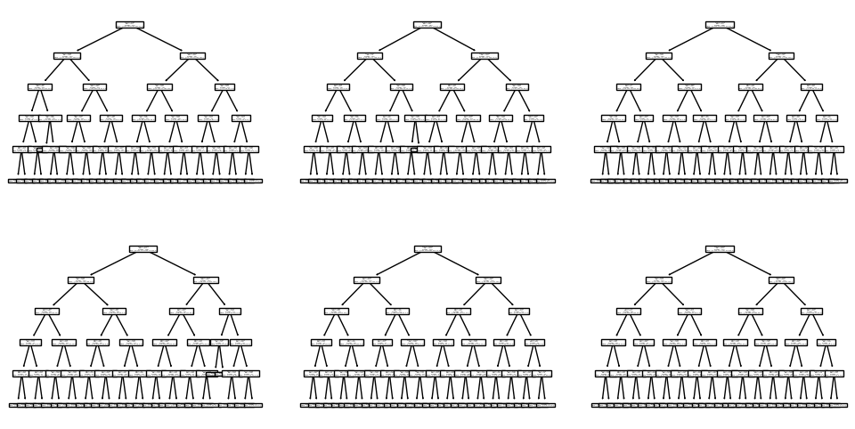
Figure 21

Bagging model score:

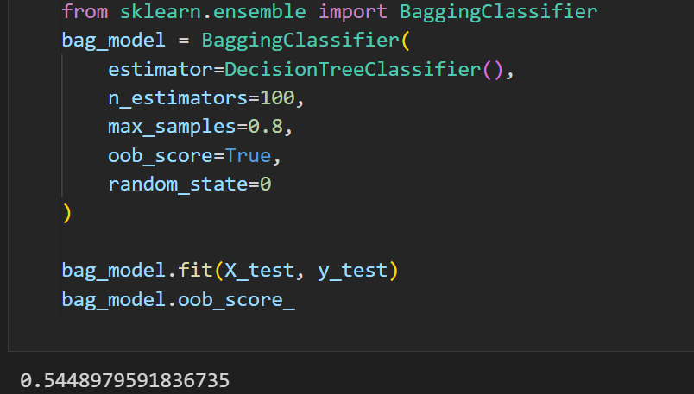

Figure 22

Confusion Matrix

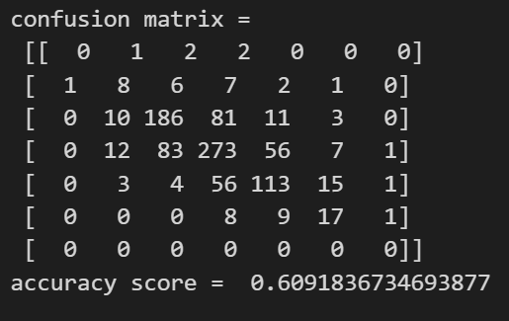
Figure 23
Plot

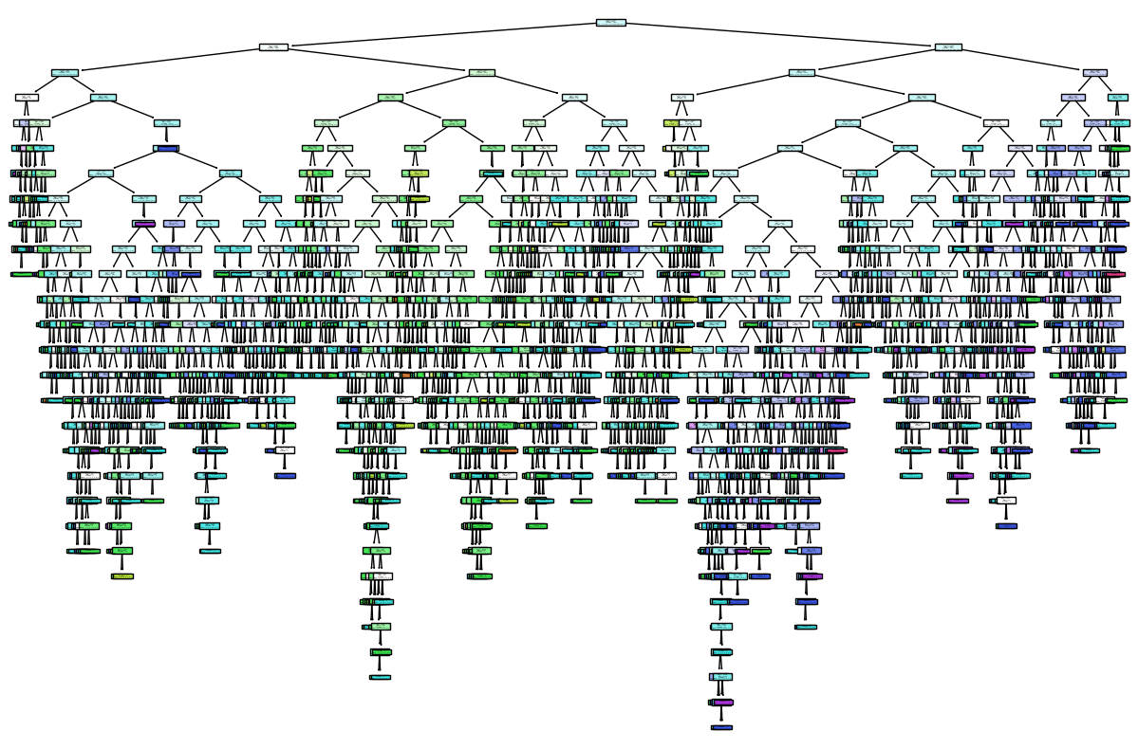
Figure 24

Evaluating Bagging Model:

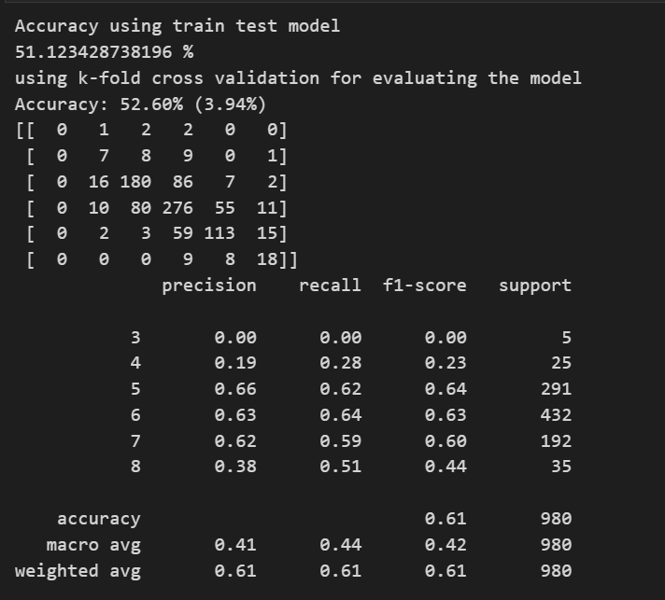

Figure 25
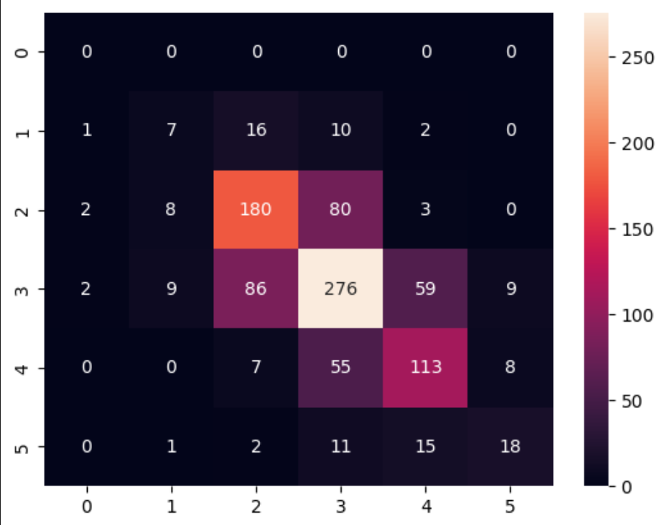
Figure 26

Evaluating XGBoost:

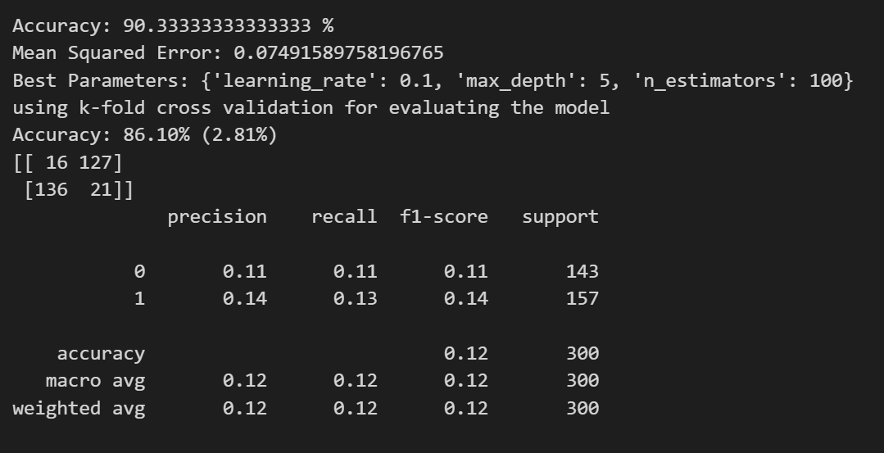
Figure 27

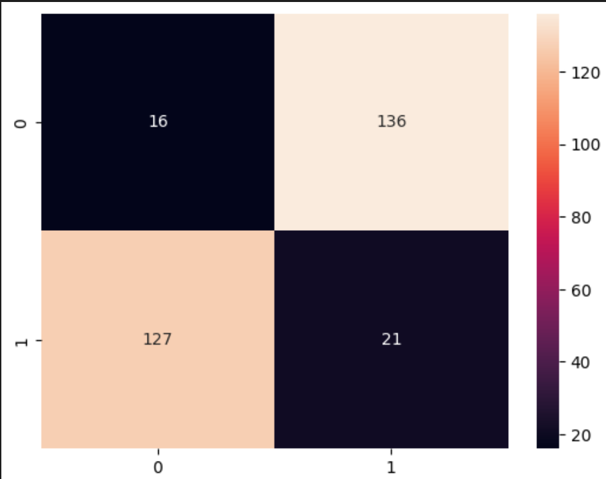
Figure 28

Evaluating AdaBoost:

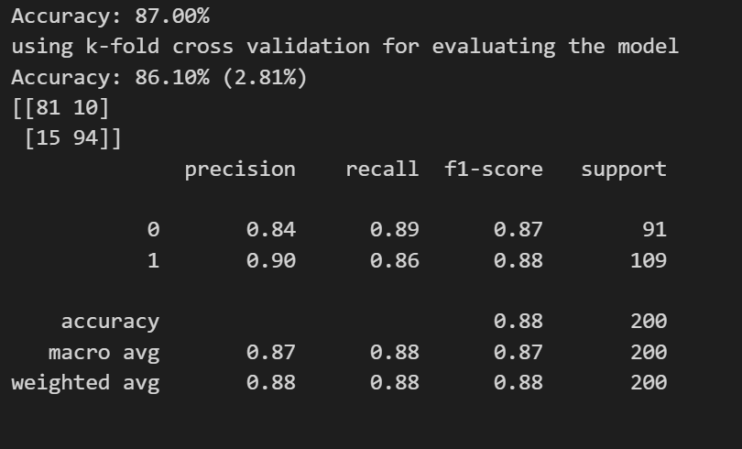
Figure 29

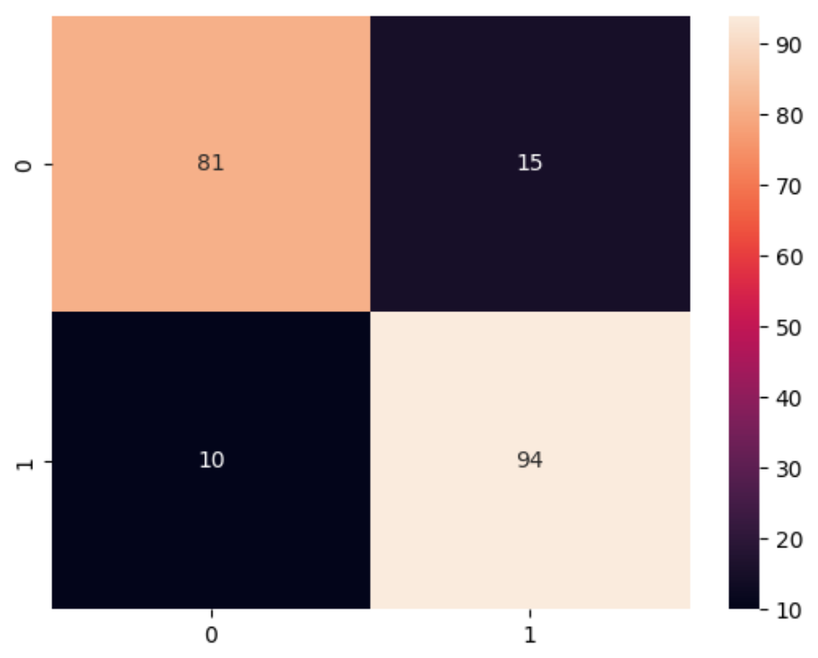
 | Evaluation measures | Accuracy | Precision | F1score | Recall | Support
Ml Model
Bagging |  | 52.60% | 41.33% | 42.33% | 44% | 163.3
Xgboost |  | 90.33% | 12.55% | 12.55% | 12% | 150
Adaboost |  | 87% | 87% | 87.5% | 87.5% | 100
Figure 30

Comparison of different ensemble techniques in form of classification table

Figure1

LIMITATIONS
48

The main problem came from the fact that our data set was unbalanced. A majority of the quality values were “regular” (5 and 6), which made no significant contribution to finding an optimal model. These values made it harder to identify each factor’s different influence on a “high” or “low” quality of the wine, which was the main focus of this analysis. In order to improve our predictive model, we need more balanced data. Another limitation worth mentioned from the data set was it only had 12 attributes, which can narrow down the accuracy of our predicting quality of red wine. The solution for this is to include more relevant data features, like the year of harvest, brew time, location, or wine type.

CONCLUSION
49

In the aim of analysing the Wine Quality, we have performed Data preparation under which we have performed data cleaning, data exploration and transformation where we removed duplicate records, checked for NA values and derived each feature’s statistical summary to detect any problem like outliers and abnormal distributions.
We tried to find which variables are likely to affect the quality of the red wine the most. We have performed a correlation analysis of the independent variables against variable, quality. The analysis gave us a list of variables of interest that had highest correlations with quality.
Then we created density plot visualizing the spread of the data, in order to analyze the relationship with the dependent variable.
After analysing the density plots, we plot the interaction between the numeric variables of interest and the dependent variable of quantity.
We performed modelling to estimate the relations between the factors effecting the quality of wine. And finally, evaluation, where we evaluated the relations and factors to predict the best quality of wine.
By analysing the physicochemical tests samples data of wines, we were able to create a model that can help industry producers, distributors, and sellers predict the quality of wine products and have a better understanding of each critical and up-to-date features. To be more specific, high-quality wines seem to have lower volatile acidity, higher alcohol, and medium-high sulphate values. Meanwhile, lower-quality wines tend to have low values for citric acid.

Accuracy: XGBoost > AdaBoost > Bagging
Precision: AdaBoost > Bagging > XGBoost
F1_Score: AdaBoost > Bagging > XGBoost
Recall: AdaBoost > Bagging > XGBoost
Support: Bagging > XGBoost > AdaBoost

By analyzing all the three ML Models on the basis of accuracy, precision, F1_score,
recall and support, the best model fitted for out wine quality dataset is AdaBoost.

So the best model fitted on our wine quality prediction is XGBoost.

FUTURE WORKS

In the future, we can try to analyse and predict quality of other products such as edible oils, hair oils, medicines, soaps and also use other and better machine learning techniques and performance metrics for better performance and comparison of results. We can also further work on this model to improve its performance and efficiency so that the prediction of the highly correlated and important factors and their concentrations to produce a better tasting and quality wine that will help the wine producers boost their sales.

APPENDIX – I (Codes)

REFERENCES
63
import pandas as pd
import numpy as np
import matplotlib.pyplot as plt
#read the data from cl
d=pd.read_csv("wine_quality(3).csv")
d.head()

d.isnull().sum()
d.describe()
d.quality.value_counts()
data=d
X=data.drop('quality',axis=1)
Y=data['quality']
Decision Tree
import pandas as pd
from sklearn.model_selection import train_test_split
from sklearn.tree import DecisionTreeClassifier
from sklearn.metrics import accuracy_score

# Load the dataset
data = pd.read_csv('wine_quality(3).csv')

# Split the dataset into training and testing sets
X = data.drop('quality', axis=1)
y = data['quality']
X_train, X_test, y_train, y_test = train_test_split(X, y, test_size=0.2, random_state=42)

# Train a decision tree on the training set
tree = DecisionTreeClassifier()
tree.fit(X_train, y_train)

# Evaluate the decision tree on the testing set
y_pred = tree.predict(X_test)
accuracy = accuracy_score(y_test, y_pred)
print('Accuracy: ', accuracy*100,'%')

from sklearn.metrics import confusion_matrix
print ( "confusion matrix = \n" , confusion_matrix(y_test, y_pred) )
print ( "accuracy score = ",accuracy_score(y_test,y_pred) )
len(y_test)
len(y_pred)

#differece between y_test and y_pred

array1 = np.array(y_pred)
array2 = np.array(y_tes
subtracted_array = np.subtract(array1, array2)
differece = list(subtracted_array)

differece

plt.hist(differece)
#subplot y_test and y_pred
plt.subplot(2,1,1)
plt.hist(y_test)
plt.title('y_test')
plt.subplot(2,1,2)
plt.hist(y_pred)
plt.title('y_pred')

l_t=y_test.tolist()

val_4_test=[]

for i in l_t:
if i==4:
val_4_test.append(i)

len(val_4_test)
l=y_pred.tolist()

val_4=[]

for i in l:
if i==4:
val_4.append(i)

len(val_4)

plt.figure(figsize=(10,10))
plt.scatter(y_test, y_pred, c='crimson')
plt.yscale('log')
plt.xscale('log')p1 = max(max(y_pred), max(y_test))
p2 = min(min(y_pred), min(y_test))
plt.plot([p1, p2], [p1, p2], 'b-')
plt.xlabel('True Values', fontsize=5)
plt.ylabel('Predictions', fontsize=5)
plt.axis('equal')
plt.show()
<h2> Bagging </h2>
from sklearn import ensemble
from sklearn.tree import plot_tree
np.random.seed(321)

clf = DecisionTreeClassifier(max_depth=5)

mdl = ensemble.BaggingClassifier(estimator=clf, n_estimators=6)
mdl = mdl.fit(X_train.values, y_train.values)

fig = plt.figure(figsize=[12,6])
for i, estimator in enumerate(mdl.estimators_):
ax = fig.add_subplot(2,3,i+1)
txt = 'Tree {}'.format(i+1)
plot_tree(estimator)
# glowyr.plot_model_pred_2d(estimator, X_train, y_train, title=txt)
from sklearn.ensemble import BaggingClassifier
bag_model = BaggingClassifier(
estimator=DecisionTreeClassifier(),
n_estimators=100,
max_samples=0.8,
oob_score=True,
random_state=0
)

bag_model.fit(X_test, y_test)
bag_model.oob_score_
#apply decision tree
from sklearn.metrics import classification_report
from sklearn.tree import DecisionTreeClassifier
dt=DecisionTreeClassifier()
dt=dt.fit(X,Y)
dt.score(X,Y)
#plot the decision tree
from sklearn import tree
plt.figure(figsize=(15,10))
tree.plot_tree(dt,filled=True)
<h3> Evaluation of Bagging </h3>
from sklearn.metrics import classification_report
from sklearn.model_selection import KFold
import seaborn as sns
import pandas as pd
import numpy as np
from sklearn.model_selection import GridSearchCV, KFold, cross_val_score
from sklearn.model_selection import train_test_split
import xgboost as xgb
from sklearn.metrics import accuracy_score, classification_report, confusion_matrix, mean_squared_error
import matplotlib.pyplot as plt
bag_model = BaggingClassifier(
estimator=DecisionTreeClassifier(),
n_estimators=100,
max_samples=0.8,
oob_score=True,
random_state=0
)

scores = cross_val_score(bag_model, X, Y, cv=5)
print("Accuracy using train test model")
print(scores.mean()*100,"%")

print("using k-fold cross validation for evaluating the model")
kfold = KFold(n_splits=10, random_state=None)
results = cross_val_score(bag_model, X, y, cv=kfold)
print("Accuracy: %.2f%% (%.2f%%)" % (results.mean()*100, results.std()*100))

# p_pred = bag_model.predict(X_test)
# p_pred = p_pred.flatten()

# y_pred = np.where(p_pred > 0.5, 1, 0)
print(confusion_matrix(y_test, y_pred))
print(classification_report(y_test, y_pred))
scores
cm = confusion_matrix( y_pred,y_test)
sns.heatmap(cm, annot=True, fmt="d")
<h1> AdaBoost
from sklearn.ensemble import AdaBoostClassifier
from sklearn.datasets import make_classification
from sklearn.model_selection import train_test_split
from sklearn.metrics import accuracy_score, precision_score, recall_score
import matplotlib.pyplot as plt
import pandas as pd
import numpy as np
import matplotlib.pyplot as plt

# generate the dataset
d=pd.read_csv("wine_quality(3).csv")
X=d.drop('quality',axis=1)
Y=d['quality']

# split into train and test sets
X_train, X_test, y_train, y_test = train_test_split(X, Y, test_size=0.3, random_state=1)

# create the model
model = AdaBoostClassifier(n_estimators=50, random_state=1)

# fit the model on the training set
model.fit(X_train, y_train)

# make predictions on the test set
y_pred = model.predict(X_test)

# evaluate the performance of the model
accuracy = accuracy_score(y_test, y_pred)
# precision= precision_score(y_test, y_pred);
# recall= recall_score(y_test, y_pred);

from sklearn.ensemble import AdaBoostClassifier
from sklearn.datasets import make_classification

from sklearn.model_selection import train_test_split
from sklearn.metrics import accuracy_score
import matplotlib.pyplot as plt

# generate the dataset
X, y = make_classification(n_samples=1000, n_features=10, n_informative=5, n_redundant=5, random_state=1)

# split into train and test sets
X_train, X_test, y_train, y_test = train_test_split(X, y, test_size=0.3, random_state=1)

# create the model
model = AdaBoostClassifier(n_estimators=50, random_state=1)

# fit the model on the training set
model.fit(X_train, y_train)

# make predictions on the test set
y_pred = model.predict(X_test)

from sklearn.ensemble import AdaBoostClassifier
from sklearn.tree import DecisionTreeClassifier
from sklearn.datasets import load_breast_cancer
from sklearn.model_selection import train_test_split
from sklearn.metrics import accuracy_score
import seaborn as sns

# Split the dataset into training and testing sets
X_train, X_test, y_train, y_test = train_test_split(X, y, test_size=0.2, random_state=42)

# Create a decision tree classifier
dt = DecisionTreeClassifier(max_depth=1, random_state=42)

# Create an AdaBoost classifier
adb = AdaBoostClassifier(estimator=dt, n_estimators=100, random_state=42)

# Train the AdaBoost classifier
adb.fit(X_train, y_train)

# Predict the test set labels
y_pred = adb.predict(X_test)

# Calculate the accuracy of the AdaBoost classifier
accuracy = accuracy_score(y_test, y_pred)
# precison= precision_score(y_test, y_pred);
# yclass= model.predict_classes(X_test,verbose=0);

print('Accuracy: {:.2f}%'.format(accuracy*100))
print("using k-fold cross validation for evaluating the model")
kfold = KFold(n_splits=10, random_state=None)
results = cross_val_score(model, X, y, cv=kfold)

print("Accuracy: %.2f%% (%.2f%%)" % (results.mean()*100, results.std()*100))
p_pred = model.predict(X_test)
p_pred = p_pred.flatten()
y_pred = np.where(p_pred > 0.5, 1, 0)
print(confusion_matrix(y_test, y_pred))
print(classification_report(y_test, y_pred))
cm = confusion_matrix( y_pred,y_test)
sns.heatmap(cm, annot=True, fmt="d")
<h1>XGBoost

# Import the necessary libraries
import pandas as pd
import numpy as np
from sklearn.model_selection import GridSearchCV, KFold, cross_val_score
from sklearn.model_selection import train_test_split
import xgboost as xgb
from sklearn.metrics import accuracy_score, classification_report, confusion_matrix, mean_squared_error
import matplotlib.pyplot as plt

# Load the wine quality dataset

# Prepare the dataset
import seaborn as sns

# Split the dataset into training and testing sets
X_train, X_test, y_train, y_test = train_test_split(X, y, test_size=0.3, random_state=42)

# Train the XGBoost model
xgb_model = xgb.XGBRegressor(objective='reg:squarederror', n_estimators=100, learning_rate=0.05, max_depth=5)
xgb_model.fit(X_train, y_train)

# Evaluate the XGBoost model
y_pred = xgb_model.predict(X_test)
accuracy = accuracy_score(y_test, np.round(y_pred))
mse = mean_squared_error(y_test, y_pred)
print('Accuracy:', accuracy*100,'%')
print('Mean Squared Error:', mse)
# plt.plot(xgb_model,[accuracy])
# Tune the XGBoost model
params = {
'max_depth': [3, 5, 7],
'learning_rate': [0.01, 0.05, 0.1],
'n_estimators': [50, 100, 200]
}

xgb_model_tuned = xgb.XGBRegressor(objective='reg:squarederror')
grid_search = GridSearchCV(xgb_model_tuned, param_grid=params, cv=3)
grid_search.fit(X_train, y_train)
best_params = grid_search.best_params_
print('Best Parameters:', best_params)
print("using k-fold cross validation for evaluating the model")

kfold = KFold(n_splits=10, random_state=None)
results = cross_val_score(model, X, y, cv=kfold)
print("Accuracy: %.2f%% (%.2f%%)" % (results.mean()*100, results.std()*100))
# predicted_labels= as.factor(max.col(xgb.pred),levels=1:8)
# obs_labels = factor(test.label,levels=1:8)
p_pred = model.predict(X_test)
p_pred = p_pred.flatten()
y_pred = np.where(p_pred > 0.5,0,1)
print(confusion_matrix(y_test, y_pred))
print(classification_report(y_test, y_pred))
cm = confusion_matrix( y_pred,y_test)
sns.heatmap(cm, annot=True, fmt="d")

- Mohana, R., Sharma, P. & Sharma, A. Ensemble Framework for Red Wine Quality Prediction. Food Anal. Methods 16, 30–44 (2023). https://doi.org/10.1007/s12161-022-02367-3

- Illya Bakurov, Mauro Castelli, Olivier Gau, Francesco Fontanella, Leonardo Vanneschi, Genetic programming for stacked generalization, Swarm and Evolutionary Computation, 10.1016/j.swevo.2021.100913, 65, (100913), (2021).

Multivariate Methods Based Soft Measurement for Wine Quality Evaluation
- https://www.hindawi.com/journals/aaa/2014/740754/

Improving Wine Data, Meredith Galante, Jan 28, 2020, Dimensional Insight:
- https://www.dimins.com/blog/2020/01/28/improving-wine-data/

Multivariate Statistical Analysis Applied in Wine Quality Evaluation:
- https://www.researchgate.net/publication/282982301_Multivariate_Stat istical_Analysis_Applied_in_Wine_Quality_Evaluation

Random Forest Classification in prediction of best quality wine, Sailaja Konda, Apr 13 2020, Medium
- https://medium.com/@sailajakonda2012/random-forest-classification- in- prediction-of-best-quality-wine-d0d7591a7c17

Analysis of Wine Quality Data
- https://online.stat.psu.edu/stat508/book/export/html/804

- Multivariate Methods Based Soft Measurement for Wine Quality Evaluation • https://www.hindawi.com/journals/aaa/2014/740754/ Improving Wine Data, Meredith Galante, Jan 28, 2020, Dimensional Insight:
- https://www.dimins.com/blog/2020/01/28/improving-wine-data/ Multivariate Statistical Analysis Applied in Wine Quality Evaluation:
- https://www.researchgate.net/publication/282982301_Multivariate_Stat istical_Analysis_Applied_in_Wine_Quality_Evaluation
- https://www.w3schools.com/python/python_ml_bagging.asp

What we did to make our project public
GitHub Link: https://github.com/LuCiFeRrdx/Wine-quality-prediction/

